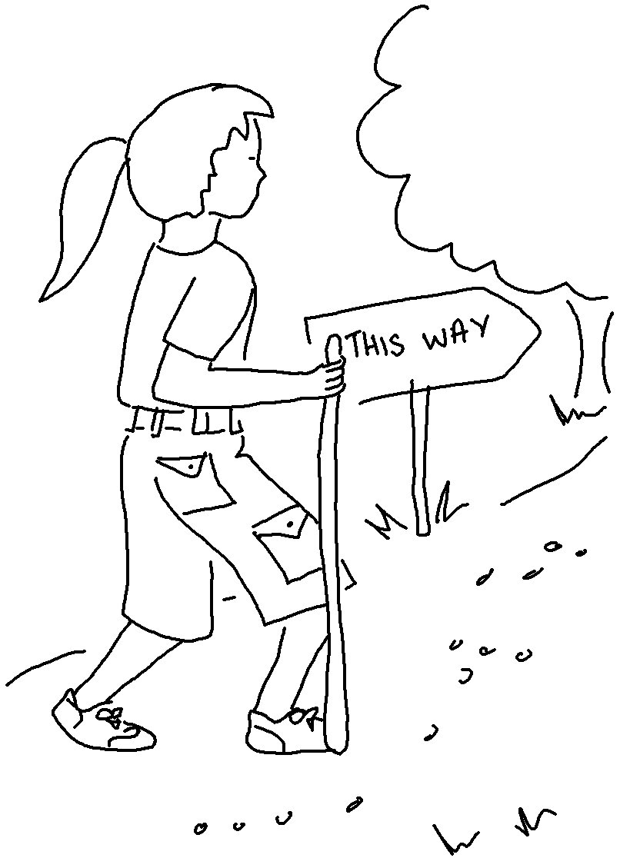
Don't say,
"I’m too young," for you must go wherever I send you. Jeremiah 1:7_{NLT}

